Supplementary Information

DEHP chronic exposure disturbs the gut microbial community and metabolic homeostasis: Gender-based differences in zebrafish

Pan-Pan Jia¹, Guang-Yuan Xin^{1,2}, Muhammad Junaid³, Yan Wang¹, Yan-Bo Ma¹, De-Sheng Pei^{1,2}*

¹Key Laboratory of Reservoir Aquatic Environment, Chongqing Institute of Green and Intelligent Technology, Chinese Academy of Sciences, Chongqing, 400714, China
²College of Life Science, Henan Normal University, Xinxiang 453007, China
³Key Laboratory for Heavy Metal Pollution Control and Reutilization, School of Environment and Energy, Peking University Shenzhen Graduate School, Shenzhen 518055, China

*Corresponding author.
E-mails: deshengpei@gmail.com and peids@cigit.ac.cn (D.S.P)
Table S1. The primers used in this study.
Name | F(5’-3’) | R(5’-3’) |  | Gene No. |  | Product Length(bp)
gapdh | GTGGAGTCTACTGGTGTCTTC | GTGCAGGAGGCATTGCTTACA |  | NM_001115114.1 |  | 173
tlr-5 | GAAACATTCACCCTGGCACA | CTACAACCAGCACCACCAGAATG |  | NM_001130595.2 |  | 70
il-1β | CCACGTATGCGTCGCCCAGT | GGGCAACAGGCCAGGTACAGG |  | NM_212844.2 |  | 91
nf- κb | AACGAGGCTGAGAGGAGTCT |  | ATCAGCCGAACCACACTGAG |  | NM_001353873.1 |  | 80
il-8(cxcl8a) | GCTTCTGATCTGCACGACTG | CCACGTCTCGGTAGGATTGA |  | NM_001327985.1 |  | 220
nf- κb | AACGAGGCTGAGAGGAGTCT |  | ATCAGCCGAACCACACTGAG |  | NM_001353873.1 |  | 80

Table S2. The developmental indexes of zebrafish after chronic exposure to DEHP.
Groups | Body length (cm) | Bodyweight (g) | Condition factor (K) | Intestinal somatic index (ISI, %) | Gonadal somatic index (GSI, %) | Hepatic somatic index (HSI, %)
0-F | 2.881±0.027 | 0.201±0.005 | 58.267±1.759 | 4.706±0.249 | 9.941±0.584 | 1.818±0.201
10-F | 3.056±0.029*** | 0.233±0.005*** | 71.491±2.035*** | 5.300±0.227 | 10.252±0.726 | 1.856±0.139
33-F | 2.956±0.028 | 0.213±0.005 | 64.328±2.033 | 5.136±0.251 | 8.705±0.567 | 1.944±0.146
100-F | 2.895±0.031 | 0.213±0.005 | 61.810±1.615 | 4.591±0.235 | 11.095±0.709 | 1.969±0.138
0-M | 2.951±0.022 | 0.193±0.004 | 57.335±1.562 | 3.334±0.215 | 0.998±0.140 | 1.118±0.150
10-M | 3.021±0.023 | 0.210±0.005* | 63.678±1.892 | 3.584±0.161 | 1.082±0.112 | 1.128±0.144
33-M | 3.068±0.036** | 0.207±0.006 | 64.659±2.450* | 3.419±0.178 | 1.037±0.152 | 1.179±0.140
100-F | 3.026±0.025 | 0.196±0.005 | 59.744±1.810 | 3.011±0.141 | 1.262±0.145 | 1.014±0.123
The data were presented as the mean ± standard error (SEM) of 12 pairs replicates of zebrafish samples in each group, and the symbols *, **, and *** indicated the significant changes with p < 0.05, 0.01, and 0.001, respectively.

Table S3. The richness and diversity indexes of zebrafish intestinal microbiotaª.
Groups | OTUs number | Shannon | Simpson | Ace | Chao | Coverage (%)
F-0 | 206.33±28.17 | 2.38±0.24 | 0.20±0.04 | 252.32±12.10 | 246.18±19.03 | 99.94±0.00
F-100 | 231.33±31.02 | 2.35±0.36 | 0.21±0.04 | 261.28±20.81 | 263.55±17.09 | 99.94±0.01
M-0 | 171.00±10.97 | 1.87±0.29 | 0.30±0.07 | 218.87±14.24 | 209.74±18.86 | 99.93±0.01
M-100 | 182.67±20.50 | 2.15±0.03* | 0.23±0.03 | 211.41±8.90 | 207.91±10.54 | 99.95±0.01
ªAll data were presented as the mean ± standard error (SEM) of three replicates in each group, and the symbol * implied the significant changes with p<0.05 between the DEHP exposed group and control.

Table S4. The changes of zebrafish gut microbiota at genus levelª.
OTU ID |  | F-0 | F-100 |  | M-0 | M-100
 |  | Percentage (%) | Percentage (%) | Fold  change | Percentage (%) | Percentage (%) | Fold  change
1 | p__Fusobacteria; g__Cetobacterium | 35.23 | 27.71 | 0.79 ↓ | 47.81 | 41.85 | 0.88 ↓
2 | p__Firmicutes; g__norank_f__Erysipelotrichaceae | 17.15 | 27.39 | 1.60 ↑ | 20.06 | 13.68 | 0.68 ↓
3 | p__Proteobacteria; g__Plesiomonas | 11.19 | 7.33 | 0.65 ↓ | 4.58 | 5.99 | 1.31 ↑
4 | p__Bacteroidetes; g__norank_f__Porphyromonadaceae | 5.85 | 4.17 | 0.71 ↓ | 6.33 | 10.62 | 1.68 ↑
5 | p__Proteobacteria; g__Aeromonas | 4.28 | 5.51 | 1.29 ↑ | 4.67 | 7.56 | 1.62 ↑
6 | p__Proteobacteria; g__Vibrio | 1.89 | 1.57 | 0.83 ↓ | 4.57 | 4.49 | 0.98 ↓
7 | p__Proteobacteria; g__Deefgea | 0.67 | 4.47 | 6.73 ↑ | 0.66 | 2.98 | 4.53 ↑
8 | p__Proteobacteria; g__Gemmobacter | 3.28 | 4.10 | 1.25 ↑ | 0.70 | 0.36 | 0.52 ↓
9 | p__Proteobacteria; g__Shewanella | 0.72 | 0.84 | 1.17 ↑ | 1.36 | 2.76 | 2.03 ↑
10 | p__Verrucomicrobia; g__Akkermansia | 1.69 | 0.67 | 0.40 ↓ | 2.22 | 0.45 | 0.20 ↓
11 | p__Actinobacteria; g__norank_o__PeM15 | 3.07 | 0.28 | 0.09 ↓ | 1.49 | 0.02 | 0.02 ↓
12 | p__Fusobacteria; g__norank_f__Hados.Sed.Eubac.3 | 0.62 | 0.23 | 0.37 ↓ | 0.99 | 1.76 | 1.79 ↑
13 | p__Actinobacteria; g__Mycobacterium | 0.48 | 2.32 | 4.85 ↑ | 0.07 | 0.31 | 4.37 ↑
14 | p__Proteobacteria; g__unclassified_f__Enterobacteriaceae | 0.84 | 0.51 | 0.60 ↓ | 0.33 | 0.43 | 1.30 ↑
15 | p__Proteobacteria; g__Meganema | 0.67 | 1.17 | 1.76 ↑ | 0.18 | 0.04 | 0.23 ↓
16 | p__Actinobacteria; g__Gordonia | 0.55 | 0.56 | 1.01 ↑ | 0.09 | 0.61 | 6.71 ↑
17 | p__Proteobacteria; g__unclassified_f__Rhodobacteraceae | 0.26 | 0.90 | 3.53 ↑ | 0.08 | 0.41 | 5.10 ↑
18 | p__Proteobacteria; g__Arenimonas | 0.59 | 0.86 | 1.46 ↑ | 0.08 | 0.07 | 0.87 ↓
19 | p__Proteobacteria; g__Rubellimicrobium | 0.62 | 0.82 | 1.32 ↑ | 0.11 | 0.04 | 0.33 ↓
20 | p__Bacteroidetes; g__Bacteroides | 0.34 | 0.20 | 0.58 ↓ | 0.54 | 0.46 | 0.86 ↓
21 | p__Proteobacteria; g__Rhodobacter | 0.73 | 0.31 | 0.42 ↓ | 0.36 | 0.02 | 0.06 ↓
22 | p__Firmicutes; g__Planococcus | 1.27 | 0.01 | 0.01 ↓ | 0.01 | 0.01 | 0.55 ↓
23 | p__Proteobacteria; g__Hyphomicrobium | 0.43 | 0.69 | 1.59 ↑ | 0.03 | 0.06 | 2.02 ↑
24 | p__Firmicutes; g__Salinicoccus | 1.08 | 0.00 | 0.00 ↓ | 0.00 | 0.00 | 0.17 ↓
25 | p__Bacteroidetes;g__Macellibacteroides | 0.07 | 0.12 | 1.77 ↑ | 0.20 | 0.54 | 2.76 ↑
26 | p__Actinobacteria; g__Iamia | 0.33 | 0.45 | 1.36 ↑ | 0.05 | 0.05 | 1.01 ↑
27 | p__Proteobacteria; g__Legionella | 0.14 | 0.56 | 3.86 ↑ | 0.04 | 0.05 | 1.08 ↑
28 | p__Verrucomicrobia; g__Haloferula | 0.02 | 0.06 | 3.28 ↑ | 0.03 | 0.34 | 13.08 ↑
29 | others | 5.94 | 6.16 | 1.04 ↑ | 2.36 | 4.05 | 1.71 ↑
ªThe data showed the richness of various genera with the average percentage (%) of replicates in each group, and the fold change of DEHP exposed female and male zebrafish was calculated by average percentages vs that of control.

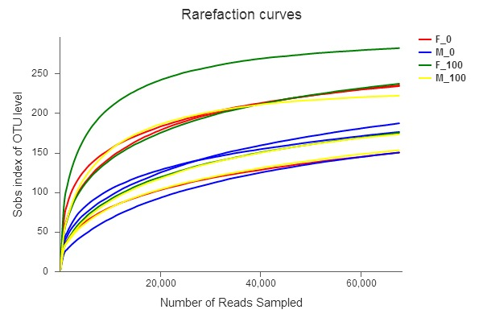
Figure S1. The rarefaction curve of sequences based on the > 97% similarity level. Different colors showed different groups with three replicate samples, and the F-0 and M-0 indicated the female and male fish in the control group.

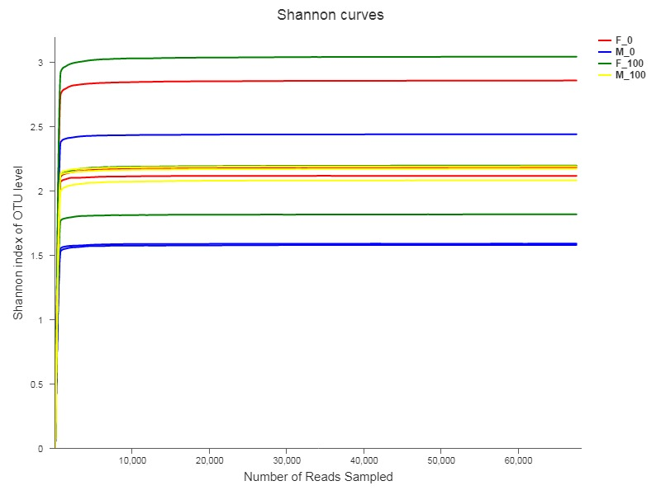
Figure S2. The Shannon rarefaction curve of sequences on OTUs level (>97% similarity level). Different colors showed different groups with three replicate samples, and the F-0 and M-0 indicated the female and male fish in the control group.
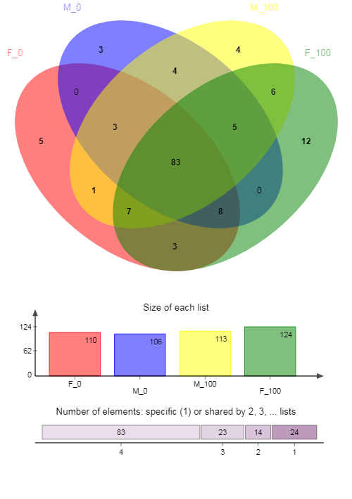
Figure S3. The Venn chart in the family level showed the similarity of each group by detecting the specific or shared family members. The shared family member by the four groups was 83, and a total of 24 families were specific from those groups. The male fish showed high similarity in control and DEHP groups, while the female fish in the F-100 group had more special families.

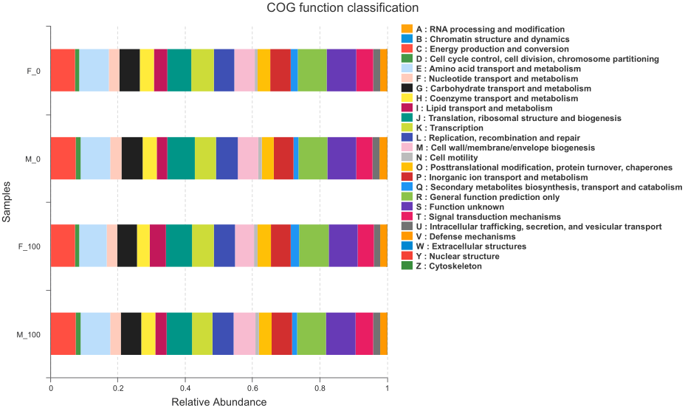
Figure S4. The abundance of mechanism pathways of zebrafish bacterial functions by COG analysis. The various mechanism pathways with different relative abundance were compared between the female and male zebrafish, as well as the DEHP exposure and control groups.

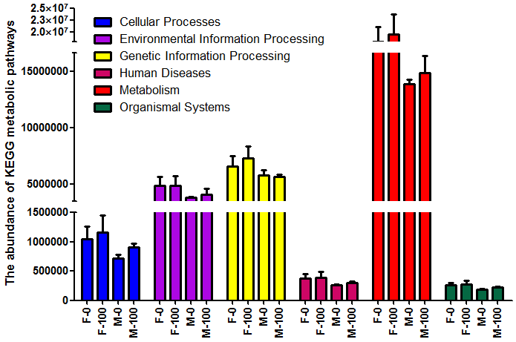
Figure S5. The abundance of mechanism pathways of zebrafish bacterial functions by KEGG analysis. The different levels of mechanism pathways were calculated from the MiSeq Illumina platform, and the metabolism pathway showed a higher level among the most critical pathways for the body health.

